**Year 8 Physical Science**

**Double Glazing Investigation**

**Aim**: To investigate the effect of double-glazing in preventing heat loss.

**Equipment**:

* 2 × 100 mL beakers
* cling wrap
* 4 cardboard discs of the same size, slightly larger in diameter than a 250 mL beaker
* stopwatch
* 2 thermometers
* hot water
* 2 x 100ml measuring cylinders
* filter funnel

**Method**:

1. Position each beaker between two cardboard discs. A disc with a hole in the centre should be on top of each beaker as shown below.
2. Wrap one beaker with three layers of cling wrap, without covering the hole.
3. Measure 80ml of hot water in two measuring cylinders.
4. Insert a filter funnel into the hole and **carefully** add 80 mL of hot water to each beaker.
5. Insert the thermometers.
6. Record the temperature in each beaker immediately, then every minute for 10 minutes.

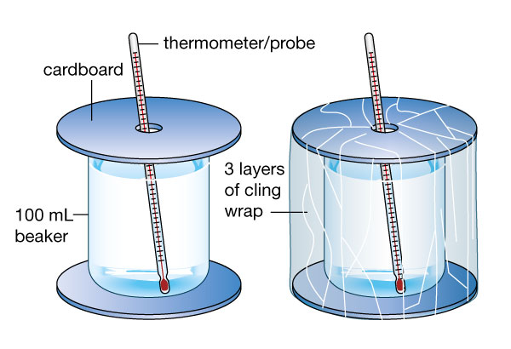

Title: ______________________________________________________________________

|  |  |  |
| --- | --- | --- |
| Time (min) | Water temperature in beaker without cling wrap (°C) | Water temperature in beaker with cling wrap (°C) |
| 0 |  |  |
| 1 |  |  |
| 2 |  |  |
| 3 |  |  |
| 4 |  |  |
| 5 |  |  |
| 6 |  |  |
| 7 |  |  |
| 8 |  |  |
| 9 |  |  |
| 10 |  |  |

**Questions**:

1. Identify the variables for the experiment

Independent variable ____________________________________________

Dependant variable ____________________________________________

Controlled variables (≥ 2) ____________________________________________

____________________________________________

1. Write a title for your table in the space provided.
2. Which beaker had the least amount of heat loss (stayed the warmest).

_____________________________________________________________________­_

*Windows which have two layers of glass with a space between them are called double glazed. Double glazed windows are designed to reduce loss of heat and exclude noise.*

1. Discuss how the beaker wrapped in glad wrap is similar to a double glazed window.

_____________________________________________________________________­_

_____________________________________________________________________­_

1. Discuss how the beaker wrapped in glad wrap is different to a double glazed window.

______________________________________________________________________

­______________________________________________________________________